

Document Name: Skype Enabled Empathy - UI design proposal
Document Number: Skype enabled Empathy-UID-001
Authors: Jessica Gillström, Matthew Paul Thomas
Contributors: Emilio Pozuelo, Danielle Madeley, Sjoerd Simons
Version: 1.2.1
Status: RFC
Date: 15 August 2011
Reviewers: Emilio Pozuelo, Danielle Madeley, Sjoerd Simons
Approval: Jessica Gillström, Alex Kaluzhny
Classification: Company Confidential

This document covers user experience and interface design for (1) “Plugged into Skype” requirements, (2) Skype certification requirements, and (3) various other Skype-related features. It does not cover audio, video, quality, or reliability requirements. All designs are subject to change, depending on discussions between Collabora and Canonical.

Version history
Author | Date | Version | Change | Status
Jessica Gillström | 03/01/11 | 0.1 | Created | Draft
Jessica Gillström | 04/01/11 | 0.2 | Updated after initial internal review | Draft
Matthew Paul Thomas | 04/02/11 | 0.2j | More detailed designs for all features | Draft
Matthew Paul Thomas | 04/02/11 | 0.3 | Moved contact blocking to Phase 2  Many other corrections | Draft
Matthew Paul Thomas | 10/02/11 | 0.4 | Listed certification requirements for Phase 2 interface changes | Draft
Matthew Paul Thomas | 17/02/11 | 0.5 | Added sketches for remaining features | Draft
Matthew Paul Thomas | 22/02/11 | 0.6.1 | Began designs for “Plugged into Skype” | Draft
Matthew Paul Thomas | 23/02/11 | 0.7 | Completed proposals for “Plugged into Skype” | Draft
Matthew Paul Thomas | 23/02/11 | 0.8 | Restructured without “Phase 1” and “Phase 2” | Draft
Matthew Paul Thomas | 25/02/11 | 0.9 | Completed designs for Skype certification | Draft
Matthew Paul Thomas | 25/02/11 | 0.9.1 | Addressed comments from Sjoerd Simons | RFC
Matthew Paul Thomas | 01/03/11 | 0.9.2 | Fixed table of contents | RFC
Matthew Paul Thomas | 09/03/11 | 0.10 | Fixed 3.1.4, 3.1.5, 3.1.6, 3.1.11, 3.1.15, 3.4.10, 3.5.3, and 4.2.3 from combined review | RFC
Matthew Paul Thomas | 15/03/11 | 0.10.1 | Restored confirmation alert for clearing history | RFC
Matthew Paul Thomas | 24/03/11 | 0.10.2 | Specified how to allow blocked video | RFC
Matthew Paul Thomas | 31/03/11 | 1.0 | All “Plugged into Skype” and certification requirements specified, except those waiting for legal or Skype feedback | Complete
Matthew Paul Thomas | 21/04/11 | 1.0.1 | Updated block dialog text; simplified History; tweaked credit balance presentation | Complete
Matthew Paul Thomas | 24/05/11 | 1.1 | History tweaks; not an embedded device; changes to Skype logo and trademark use and privacy settings; possible enhancements for offline with voicemail, Skype sounds, and country codes | RFC
Matthew Paul Thomas | 15/07/11 | 1.2 | Added rough specification for “More obvious audio/video calls” and “Group calls” | RFC
Matthew Paul Thomas | 15/08/11 | 1.2.1 | Added “Seeing people on a group call” | RFC

Table of Contents
Version history 2
Plugged into Skype™ requirements 5
2. Testing related requirements 5
2.1.1. End-user documentation 5
3. Testable generic legal requirements 5
3.1.1. EULA for Developed Product 5
3.1.2. Skype sign-in 5
3.1.3. Skype EULA 6
3.1.4. Skype sign-out 6
3.1.5. Clear instant message history 7
3.1.6. Privacy settings 7
3.1.7. Accepting/rejecting file transfers 10
3.1.8. Protect hyperlink handling 10
3.1.9. Skype password changing 10
3.1.10. No non-account access to Skype features 10
3.1.11. Customer support information 11
3.1.14. No features similar to Skype Paid For features 11
3.1.15. No multi-instance usage with consumer accounts 11
3.1.16. Software update notification 11
3.1.17. No emergency calls with Skype 12
3.1.18. No advertisements related to Skype 12
3.2. Branding related requirements 12
Skype certification requirements 14
2. Documentation requirements 14
3. Functional implementation based requirements 14
3.2. Optional: Account creation 14
3.3. Mandatory: Change password 14
3.4. Optional: Call functionality — General 14
3.5. Optional: Call functionality — Calling phones and mobiles 18
3.6. Optional: Call functionality — Conference calls 20
3.7. Optional: Contact management 20
3.8. Optional: Chat 20
3.9. Optional: File transfer 22
3.10. Optional: Skype contact search and adding contacts 23
3.11. Optional: SMS 24
3.12. Optional: Video 24
3.13. Optional: Public conversations — hosting 24
3.14. Optional: Public conversations — participating 24
4. Quality and reliability requirements 25
4.1. General quality requirements 25
4.2. Embedded Skype device requirements 25
Possible further enhancements 26
Showing “Offline with voicemail” status 26
Skype-specific sounds 26
Country calling code help when dialling a number 26
On-demand installation of Skype module 27
Voicemail 29
Skype certification requirements 29
Voicemail settings 29
Sending an incoming call to voicemail manually 30
Being notified of voicemail 30
Playing back voicemail received 31
Leaving a voicemail message 32
SMS 33
Skype certification requirements 33
Refined search and adding of contacts 33
Skype certification requirements 33
Adding a contact 34
Showing full profile information 37
Incoming authorization requests 37
Built-in account creation 38
Skype certification requirements 38
Built-in password changing 41
Skype certification requirements 41
Call holding/switching 42
Skype certification requirements 42
More obvious audio/video calls 42
Group calls (conference calls) 43
Setting up a group call 43
Joining a group call, knowing who’s on it 44
Adding someone to a group call 44
Cancelling adding someone to a group call 45
Seeing that someone else is adding someone to a group call 45
Removing someone from a group call 45
Understanding that Skype disallows video on a free group call 46
Telling who is talking on a group call 46
Showing that a chat message was edited 46
Editing your own chat messages 46
Public conversations — participating 46
Public conversations — hosting 46
Avoiding frustration from muted sound 46

Plugged into Skype™ requirements

2. Testing related requirements

2.1.1. End-user documentation
Env. Needs: The user manual should be available. Input: Using the user manual as input, verify that a selection of documented operations/use-cases work as written. Review the product to check if some Skype functionality is not covered. Output: Operations work as intended. Operations invoke no errors native to the device or application. Skype related functionality is covered in the user manual.
There should be a simple mechanism for the Empathy help to include help pages — and paragraphs within pages — specific to the Skype functions whenever the Skype integration code is installed, and not to include them when it isn’t. This may involve moving the Empathy help into the Empathy codebase.
(Specific help topics are not covered in this specification, since that is out of scope for the Collabora work.)

3. Testable generic legal requirements

3.1.1. EULA for Developed Product
SkypeKit Distribution Terms 5.2: You shall provide and require each End User to agree to your own end user licence agreement (“EULA”) for your Developed Product…
The first time anyone logged into a particular Ubuntu user account chooses “Add”, “Sign In”, or equivalent for a Skype account, an “End User License Agreement” dialog should appear. (Canonical will provide the text of the agreement.) If you choose “Decline”, the interface should return to exactly where it was before you chose “Add” or “Sign In” (the account should not be added or signed in to).
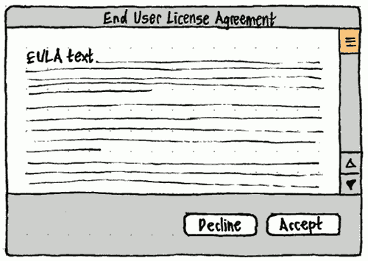

3.1.2. Skype sign-in
SkypeKit Distribution Terms 6.7 (a): Your Developed Product must include functionality which allows End Users to log into their Skype Account through your Developed Product and only allow the use of Skype Features through Skype Accounts by End Users directly. The log-in functionality must be presented at least as prominently, but not more prominently, as any other log-in functionality available on or through your Developed Product and in a manner compliant with the plugged into Skype guidelines.
No work required.

3.1.3. Skype EULA
SkypeKit Distribution Terms 5.1: You must ensure that each End User that creates a new Skype Account from your Developed Product agrees to the Consumer EULA and Consumer TOS or Business EULA and Business TOS (as applicable) and the Skype Privacy Policy prior to creation of the Skype Account.
No work required. At this stage, Empathy will defer to Skype.com (which shows the Skype EULA itself) for creating a new account.

3.1.4. Skype sign-out
SkypeKit License Agreement 6.7 (b): Your Developed Product must allow End Users to log out of the Skype Features and cancel auto-login (or “remember me”)
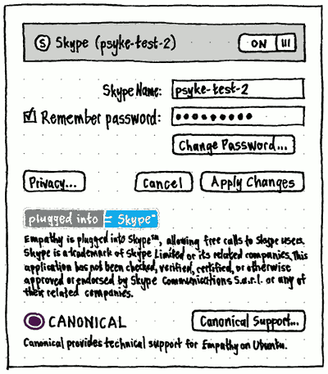
In the account settings for a Skype account, the label for the password field should be a “Remember password” checkbox. Whenever the checkbox is unchecked, the password field should be insensitive and empty. If “Remember password” is checked when you open the pane, the password field should be pre-filled with twelve bullets, even though Empathy does not know the exact password length; and selecting, deleting, or typing alongside any of those bullets should respectively select, delete, or delete all of them instantly.

3.1.5. Clear instant message history
SkypeKit License Agreement 6.7 (c): Your Developed Product must allow End Users to clear Instant Message history (where such Skype Feature is enabled)
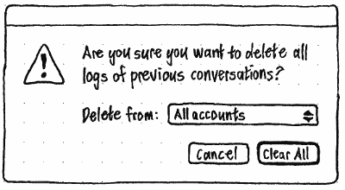
The “Previous Conversations” or “History” window should have an “Edit” menu containing a “Delete All History…” item. Activating the item should open a confirmation alert containing a menu for choosing which accounts you want to clear the history of. The menu should consist of an “All accounts” item (with no icon), then a separator, then items (with icons) for each account you’ve ever had that has history recorded. The default selection in the menu should be the same as the currently viewed account(s) for the History window itself.
Alternatively: Introduce a “Select All” menu item for selecting all history items from the currently viewed account(s), plus a “Delete” command for deleting whichever history items are selected.

3.1.6. Privacy settings
SkypeKit License Agreement 6.7 (d): Your Developed Product must make available all privacy settings for the Skype Features, including the ability to manage blocked users and report abuse

Privacy settings
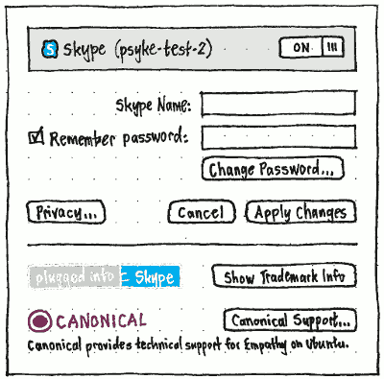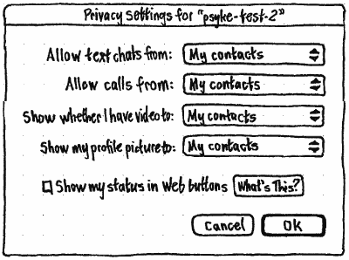
The account settings pane for a Skype account should have a “Privacy Settings…” button that opens a ‘Privacy Settings for “{Skype name}”’ dialog. (The “Privacy Settings…” button may need to be insensitive whenever you are offline for the account.)
Following the SkypeKit User Experience Guidelines:
- The “Allow text chats from:” menu should have options “Anyone” and “My contacts” (the default).
- The “Allow calls from:” menu should have options “Anyone” and “My contacts” (the default).
- The “Show whether I have video to:” menu should have options “Anyone”, “My contacts” (the default), and “No-one”.
- The “Show my profile picture to:” menu should have options “Anyone” and “My contacts” (the default).
- The “Show my status in Web buttons” checkbox should be unchecked by default.
The “What’s This?” button should open the default Web browser to <http://www.skype.com/intl/en/share/buttons/>.

Removing and blocking a contact and reporting abuse
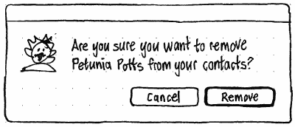
Normally, the “Remove” command should produce an alert with “Cancel” and “Remove” buttons, with “Remove” being the default. But if the contact is from Skype or any other server that allows blocking people (or if it is a meta-contact where at least one of its accounts can be blocked), the Remove alert should have “Remove and Block”, “Cancel”, and “Remove” buttons, with “Remove and Block” being the default. (This layout is unusual in that the default button is not on the trailing side, but it preserves consistency of layout with the non-Skype case while also complying with the Skype certification requirement.)
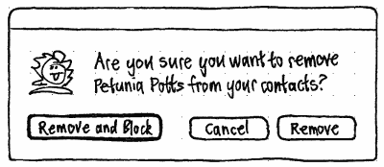
For a meta-contact where not all of its accounts are of types that can be blocked, this second variation of the alert should appear, but with additional secondary text: “Blocking will block only calls and chats from the accounts {comma-separated list of account display names}. It will not block calls or chats from {comma-separated list of account display names}.”.
Separately from the “Remove” command there should be a “Block” command (because you may wish to block someone who isn’t in your contacts). If the person in question has an associated Skype account (or an account of any other type that allows reporting abuse), the confirmation alert for blocking should offer the option to report the account as abusive.
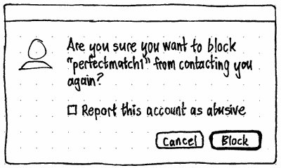

Managing blocked users
At the end of the “View” menu should be a “Blocked Contacts” item. Selecting the item should flip the Contacts window into a “Blocked contacts” view.
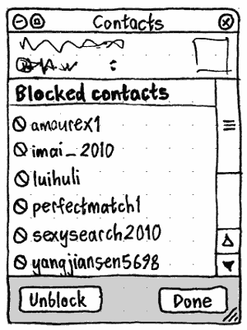
The “Unblock” button should be sensitive whenever a blocked contact is selected.
The “Done” button should flip the window back into the normal contacts view.

3.1.7. Accepting/rejecting file transfers
SkypeKit License Agreement 6.7 (e): Your Developed Product must ensure that End Users have the ability to accept/reject file transfers (where such Skype Feature is enabled)
No work required.

3.1.8. Protect hyperlink handling
SkypeKit License Agreement 6.7 (f): Your Developed Product must protect hyperlink handling in Instant Messages to protect the End User from receiving malicious URLs (where such Skype Feature is enabled)
We don’t know what this means. Collabora and Randy Linnell are trying to find out from Skype.

3.1.9. Skype password changing
Your Developed Product must allow End Users to configure Skype Account password.
In the account settings for a Skype account, below the password field should be a “Change Password…” button that opens the default Web browser to <https://secure.skype.com/account/personal/change-password>.

3.1.10. No non-account access to Skype features
SkypeKit License Agreement 6.8 (h): Your Developed Product shall not enable access to the Skype Features other than through a Skype Account.
No work required.

3.1.11. Customer support information
SkypeKit Distribution Terms 5.4: You shall be solely responsible for any and all product and End User support and/or product warranties relating to your Developed Product. You shall inform the End User that you shall be solely responsible by way of a conspicuous visual indicator and you shall provide complete and accurate contact information to enable the End User to contact you. To the extent that any Developed Product generates an unreasonable demand for customer services support from Skype or generates negative customer comment for Skype, Skype will exercise its right to terminate these Distribution Terms.
The account settings for a Skype account should end with a Canonical logo, a “Canonical Support…” button that opens the default Web browser to <http://canonical.com/support?app=empathy>, and the caption “Canonical provides technical support for Empathy on Ubuntu.”.

3.1.14. No features similar to Skype Paid For features
SkypeKit License Agreement 6.14: Your Developed Product will not include, offer, enable or make available Similar Features to any Skype Paid For Features. If Skype adds any Skype Paid For Features and/or revises the list of Similar Features, then you must bring your Developed Product into conformance with this Section 6.14 or this Agreement and all rights granted to you hereunder will automatically terminate.
No work required. Steve Pearce says this applies only to abusing SkypeKit, for example offering a way to call on PSTN over a Skype account by any method other than SkypeOut.

3.1.15. No multi-instance usage with consumer accounts
SkypeKit License Agreement 6.15: For Multi-Instance Usage the following restrictions apply (a) you must configure your Developed Product to require that one Instance of the applicable SkypeKit Software be Run per call; (b) your Developed Product must not be able to process or handle two or more concurrent calls per Instance.
It should be possible to add more than one Skype account. And when any new Skype account is added, it should be enabled by default. But enabling any Skype account should automatically disable any other Skype accounts. No special interface text for this is required (though it may be explained in the help).
At least until call holding is implemented, answering one call should automatically hang up any simultaneous calls.

3.1.16. Software update notification
SkypeKit License Agreement 7.2: In the event that Skype deems in its sole discretion any software included in the SkypeKit to contain material defects or to present any material security, usability or regulatory risks (in Skype’s sole discretion), you shall immediately upon notice from Skype, cease using the relevant version of such software and upgrade (and require End Users to upgrade) to a new version of such software. Input: Consult the manual to find out whether the option to upgrade is available. If something related to upgrading can be initiated manually then try it out. Output: According to end-user documentation, it is possible to upgrade.
Neither Empathy nor Ubuntu can possibly enforce software updates (an administrator could remove access to the updates repository, for example), but Skype servers can enforce them.
If an error returned for any Skype communication indicates that the SkypeKit version is too old to use, Empathy should display a standard error alert with primary text “Sorry, Skype accounts can’t be used until your Skype software is updated.” On Ubuntu, in addition to the “OK” button, the alert should have a “Check for Updates” button that launches Update Manager.

3.1.17. No emergency calls with Skype
SkypeKit License Agreement 6.9: The SkypeKit and Skype Features do not support any emergency calls to any type of hospitals, law enforcement agencies, medical care units or any type of emergency services of any kind. If, by using your Developed Product, you are obliged by any applicable law or government regulation to offer emergency calling, it is your responsibility to comply with such laws and/or regulations and you hereby agree to comply therewith. It is your responsibility to inform End Users that the Skype Features do not support emergency calling.
No work required. The Skype End User License agreement already notifies users that Skype cannot be used for emergency calls.

3.1.18. No advertisements related to Skype
No work required.

3.2. Branding related requirements

“Plugged into Skype” and “Skype” trademarks
3.2.1 | Your Developed Product must use the plugged into Skype messaging
3.2.2 | The plugged into Skype messaging must not be the most prominent element on any component related to your Developed Product
3.2.3 | The term “plugged into Skype” must indicate that your Developed Product uses SkypeKit software
3.2.4 | The plugged into Skype logo must be used only in approved versions
3.2.6 | You must never change, modify or alter the element Skype in any way
3.2.5 | You must use the trade mark symbol the first time you use the word Skype
3.2.7 | Skype trademark notice must be provided
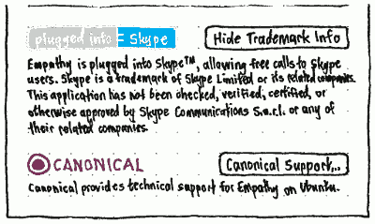
The account settings pane for a Skype account should contain an unmodified version of the “plugged into Skype™” logo, exactly as high as a “Show Trademark Info” button on the opposite side. Clicking that button should change its text to “Hide Trademark Info”, and reveal the fine print below: ““Empathy is plugged into Skype™, allowing free calls to Skype users. Skype is a trademark of Skype Limited or its related companies. This application has not been checked, verified, certified, or otherwise approved or endorsed by Skype Communications S.a.r.l. or any of their related companies.”
Below that, the Canonical logo below should similarly be exactly the height of the “Canonical Support…” button on the opposite side.

Other branding
3.2.8 | The Skype Presence Icons or Call Buttons must only be used in the latest provided form
3.2.9 | You must not adopt marks, logos or any other features that are confusingly similar to any Skype Brand Elements or variations thereof
3.2.10 | You must not copy or imitate the Skype trade dress
Buzz | Using different status icons is “okay”, as long as we represent call forwarding separately from normal Available status. We may use the Skype logo to represent a Skype account.
In the Accounts settings and elsewhere, Empathy should use the Skype logo to represent a Skype account.
Empathy’s presence icons, call button graphics, and default profile icons should be noticably distinct from those used in Skype’s own client.

Skype certification requirements

2. Documentation requirements
No work required. Help pages and printed materials are currently outside the scope of the Collabora work.
2.1.1. | The solution functions according to the manual
2.1.2. | The vendor’s customer support contact information is provided in the User Manual
2.1.3. | The end-user documentation is straightforward and explicitly documents all functions of the product
2.1.4. | Printed Quick Guide or User Manual is included
2.1.5. | Product attributes are consistent on all submission deliverables
2.1.6. | Product packaging has been designed according to the Skype Packaging Toolkit for Partners

3. Functional implementation based requirements

3.2. Optional: Account creation
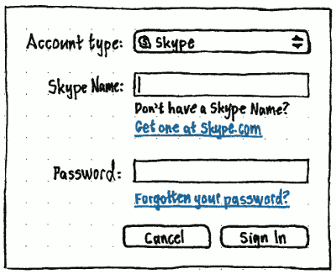
No work required. Empathy should link to Skype.com for creating a new account.

3.3. Mandatory: Change password
No extra work required. Should already be implemented for “Plugged into Skype” requirement 3.1.9.

3.4. Optional: Call functionality — General
These requirements are not optional, because Empathy already allows calling.

3.4.1. The device must enable adjusting the call and ringing volume
Empathy already allows adjustment of the call volume.
To let you adjust the ringing volume, the “Sounds” or equivalent panel in the Preferences window should have a slider at its bottom.
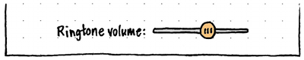
So that you can hear the effect without getting someone to call you, whenever you mouse down on, press Space on, drag, or otherwise move the slider, the ringtone should play — for its natural duration, or five seconds, whichever is shorter — at the volume represented by the slider’s current position.

3.4.2. The device must be able to provide an audible notification about an incoming call
No work required. Empathy already provides audible notification.

3.4.3. The user should be able to put a call on hold or mute the microphone
No work required. Empathy has a button in its call window for muting the microphone.

3.4.4. The device must be able to handle an interrupting call
No work required. Empathy automatically rejects interrupting calls.

3.4.5. The call must end after one party terminates it
No work required.

3.4.6. The device must enable the user to accept an incoming call (and contact name is displayed)
No work required.

3.4.7. The device must enable the user to reject a call
No work required.

3.4.8. The device must provide feedback about the call’s status
No work required.

3.4.9. The user should be able to leave a voicemail
No work required.

3.4.10, 3.4.11. History requirements
3.4.10 | In-call history events must differ visually: outgoing call, incoming call, missed call, voicemail sent, voicemail received.
3.4.11 | The user must be able to call a contact listed in a history entry.
4.2.9 | A history of previous events is provided.
The current “Previous Conversations” window is tailored to displaying transcripts of text conversations. The window would extend fairly easily to displaying SMSes, but cannot understandably present audio or video calls, missed calls, or voicemail.
To fix this, the two-tab “Previous Conversations” window should be simplified into a “History” window with no tabs, three filter panes, a transcript pane to show all the various kinds of events that Empathy records, and a toolbar with buttons for communicating with contacts listed in history entries. (This design will also make the history easier to browse and search even for people who are not using the Skype integration.)
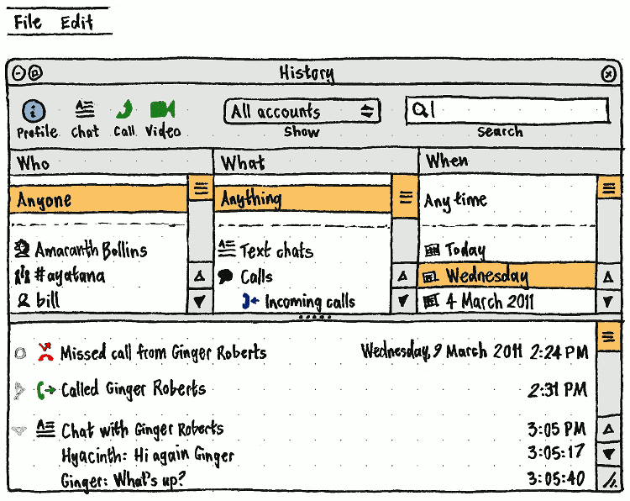
When the History window first opens, or while a search or filter operation is being performed that has taken at least one second so far, the toolbar should temporarily contain a spinner.
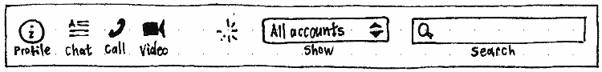
In the toolbar, the “Profile”, “Chat”, “Call”, and “Video” buttons should be sensitive whenever a single contact is selected in the “Who” pane, or whenever an event is selected in the transcript pane. The “Chat”, “Call”, and “Video” buttons should be insensitive, however, whenever the person in question is a blocked contact, or when communicating that way with them is known not to be possible right now. The “Show” menu should consist of an “All accounts” item (without icon), a separator, then items (with icon) for the union of {every account you currently have, even those you have no logged communications in} and {every account you have logged communications in, even those you no longer use}.
In each of the the three filter panes, multiple items should be selectable in the usual way (Shift click, Shift arrows, Ctrl click, Ctrl arrows, Ctrl Space). However, at all times, either the first item (“Anyone”, “Anything”, or “Any time”) should be selected or at least one other item should be selected. If the first item is selected and you select any other item, that should automatically deselect the first item. And if you deselect the only selected item (or it disappears), that should automatically select the first item.
The “Who” pane should contain “Anyone” (the default), a separator, and then a list of items for the union of {every contact currently in your contact list, even those you have no logged communications with} and {every contact you have logged communications with, even those not currently in your contact list}.
- If the search field is non-empty, the list should be filtered to contacts with whom you have ever had text chats or messages matching the search text.
The “What” pane should contain items for:
- “Anything” (the default, with an appropriate translator note to explain its context)
- a separator
- “Text chats”
- “SMS” (in Phase 2)
- “Calls”
  - “Incoming calls”
  - “Outgoing calls”
  - “Missed calls”
- “Voicemail” (once implemented)
  - “Voicemail received”
  - “Voicemail sent”
If the search field is non-empty, the list should be filtered to event types that you have ever had matching the search text. Similarly, if something other than “Anyone” is selected in the “Who” pane, the list should be filtered to types of communication that you have had with any of those contacts on any of those dates.
The “When” pane should contain “Any time”, a separator, and then an item for every date on which any communication has been recorded (with the most recent of those dates being the default).
If the search field is non-empty, the list should be filtered to event types that you have ever had matching the search text. Similarly, if something other than “Anyone” is selected in the “Who” pane, or something other than “Anything” is selected in the “What” pane, the list should be filtered to dates on which you have had any of those types of communication with any of those contacts.
The transcript pane should contain an item for each event that matches the current search text and filter selections, oldest first. The pane should update immediately whenever the search text and filter selections change. Whenever you narrow or broaden an existing filter, it should scroll so that the items currently visible in the pane do not move. In all other cases, it should be scrolled to the bottom by default, so that the most recent items are visible.
Each event should be selectable. It should have an icon representing the event type, and a timestamp (including the date, for the first event shown for each date shown).
For history purposes, a conversation is a group of instant messages to/from the same participant(s) where the maximum gap between messages is less than 30 minutes. In the transcript pane, a conversation should be shown as a single item, collapsed by default, expandable to show the conversation transcript. If a conversation spans multiple days, it should show up in the history for all relevant days.
Each call event should also be collapsed by default, expandable to show the call’s duration and end time.
Examples of possible future enhancements (not part of this project):
- Add dynamic counts for each list item in each filter pane, e.g. “Basil Fawlty 2”.
- Add the ability to “Forget” or “Clear” items (not to be confused with “Delete” for voicemail messages).
- Add “Edit” → “Copy”, “Edit” → “Find Next”, “Edit” → “Find Previous”, and the standard “Help” menu to the History window.
- Add “File” → “Print…”.
- Add “View” → “Blocked Contacts”, to toggle display of events for blocked contacts.
- A meta-contact should be represented as an expandable item, collapsed by default, so that if necessary you can expand it and choose an individual sub-contact.
For more information and discussions see the bug report:
https://bugzilla.gnome.org/show_bug.cgi?id=619866

3.5. Optional: Call functionality — Calling phones and mobiles

3.5.1. Handling emergency calls
Input: Try to initiate an emergency call over Skype from the device under testing. The list of emergency numbers: 999, 112, 997, 051, 961, 110, 17, 100, 532, 000, 101, 190, 111, 123, 191, 117, 119, 08, 911, 0112. Output: The call over Skype fails and [an] informative error message is provided (for example: “You cannot use Skype to call emergency services” with other suggestions for what to do).
If you try to call an emergency number, an error alert should appear with primary text “You cannot use Skype to call emergency services.” and secondary text “Call from a landline or mobile phone instead.”.

3.5.2. The user must be able to send DTMF tones during a call to a phone or mobile
No work required. Empathy already provides a keypad for use during a call.

3.5.3. The device must enable the user to dial phone numbers that are not in the contact list
The “New Call” dialog should be extended to allow entering phone numbers as well, where you have any accounts that allow phone calling, with a button for toggling the visibility of a keypad.
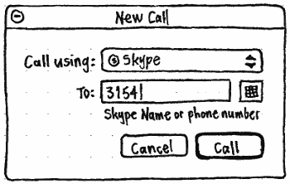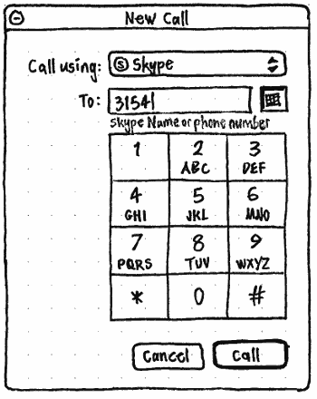
The “To:” field should show an auto-complete menu for text matching any of your contacts in the selected account, but should also allow entry of a non-contact ID. Whenever the selected account allows phone calls, the field should also allow entry of a phone number, and should be followed by a button for toggling visibility of a keypad. Using the keypad with a pointing device should keep focus on the “To:” field.
The caption for the “To:” field should depend on which account is selected and whether that account allows phone calls: for example, “Skype Name or phone number”.
The “Call” button should be insensitive whenever the “To:” field is empty.

3.5.4. The device must inform the user if the account balance is too low to place a call
Input: Make a call to a number in a location where 1 minute costs more than the available account balance. Output: The call fails and an informational message appears (for example: “You need to have Skype Credit in order to place this call” with instructions for how to buy Skype Credit).
If a call you attempt fails because there is not enough Skype credit, an error alert should appear with the primary text “Sorry, you don’t have enough Skype Credit for that call.”, secondary text “Your current balance is {balance}.”, and buttons “Cancel” and “Buy Skype Credit…”. Choosing “Buy Skype Credit…” should open the default Web browser to <http://go.skype.com/store.buy.skypecredit>.

3.5.5. The SkypeCredit balance and currency must be displayed correctly
Input: Go to Skype Account page on the Web. Change currency: EUR / USD / JPY / GBP / PLN / BRL / SEK / DKK / HKD / CHF / NOK / CAD / AUD / TWD. Output: The amount of Skype Credit should change on the device according to Web rates. Symbols must be displayed correctly.
Whenever you have at least one account configured that has a credit balance, the “View” menu should have a section containing:
- A “Credit Balance” checkmark item. Whenever this item is checked, a credit bar should be present near the top of the Contacts window. The credit bar should show the protocol logo and account ID at the leading end, and your credit balance with currency and a tiny “Top Up…” button at the trailing end. Whenever the window is too narrow, the account ID should be ellipsized at the end to make way for the credit balance.
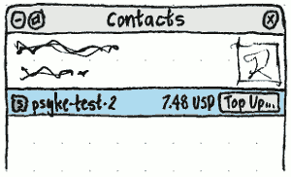
- An item, for each account which has a known way of topping up its credit balance, of the form “Top Up {account display name}… ({balance} {currency})”. For example, “Top Up psyke-test-2… (114.08 NOK)”.
Clicking a “Top Up…” button, or choosing a “Top Up…” menu item, should start the process of topping up that account. For example, for a Skype account it should open the default Web browser to <http://go.skype.com/store.buy.skypecredit>.

3.6. Optional: Call functionality — Conference calls
No work required. Empathy does not allow conference calls.

3.7. Optional: Contact management
These requirements are not optional, because Empathy already has contact management.
3.7.1 | Contact statuses must be displayed correctly for each contact who has authorized the user. Status changes must be updated within 15 minutes.
3.7.2 | Contacts must display correctly. The given name must be displayed if available; otherwise the full name, if that is available; otherwise the Skype Name.
3.7.3 | The contact list must be available in one minute for a “new” user.

3.7.4. Deleting a contact
The device must enable the user to remove, or remove and block, a contact. Remove and block is the default selection.
No work required. This should already be implemented as part of “Plugged into Skype” requirement 3.1.6.

3.8. Optional: Chat
These requirements are not optional, because Empathy already has chat.

3.8.1. The device must enable access to current chats
No work required. The window manager and/or Empathy tabs already provide access to current chats.

3.8.2. The user must be able to start a chat
No work required.

3.8.3. The user must be able to remove a chat from the list of ongoing chats
No work required.

3.8.4. The device must be able to handle unsupported chat features
Purpose: If the device does not support an action initiated by the other party, it must not crash or affect performance.

3.8.5. The device must inform the user if the chat message is not delivered
Input: 1. Initiate a chat to an offline contact from the device under testing. 2. Initiate a chat to a contact who is using a device that does not support chat from the device under testing. Output: Informative messages are displayed that differentiate the scenarios described above. Preferably in the second case, the device could offer some other ways to contact the person given the capabilities of their current solution.
No work required. Steve Pearce says that since Skype has offline storage of chat messages, no error is returned in this case.
At what point do we know that someone is on a device that can’t chat?

3.8.6. Each chat message must be related to the sender
No work required.

3.8.7. Chat messages must have visible time stamps
No work required. The default Empathy theme in Ubuntu 10.10 satisfies this requirement.

3.8.8. The device must enable the user to adjust privacy settings
No work required. This should already be implemented as part of “Plugged into Skype” requirement 3.1.6.

3.8.9. Edited chat messages must be displayed properly
Input: Initiate a chat. Send some messages from both parties. Edit a sent message from the remote end. Output: The message is properly displayed in its edited form by the device under testing.

3.8.10. The device must display other contact name in one-to-one chat
No work required.

3.8.11. The device must enable access to the list of multi-chat participants
Input: Initiate a multi-chat with at least 20 participants or use a test account with such a conversation. Make sure that the information about the other participants is displayed or accessible. Output: Information about all participants is accessible.
No work required.

3.8.12. The device must enable the user to leave a multi-chat
No work required.

3.9. Optional: File transfer
These requirements are not optional, because Empathy already has file transfer.

3.9.1. The device must provide feedback about file transfer status
No work required.

3.9.2. The device must inform the user if an incoming file is too large
Purpose: The user must be informed in case the incoming file requires more space than available. This has to be done before the user can accept the transfer.
If the folder in which received files are stored does not have enough free space for an incoming file, then for as long as Empathy uses standard alert boxes for file receipt confirmations:
- An alert for confirming the file receipt should appear, regardless of the value of the “Automatically receive files from” setting.
- That alert should, however, be different from the standard file receipt alert:
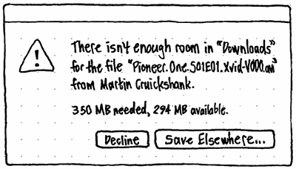
- It should use the stock warning icon.
- Its primary text should be ‘There isn’t enough room in “{folder}” for the file “{filename, ellipsized if necessary}” from {sender}.’.
- Its secondary text should be “{size} needed, {size} available.”, where the sizes are rounded to one decimal place in the most appropriate units, e.g. “780.0 MB” or “41.8 GB”.
- Its buttons should be “Decline” and “Save Elsewhere…”. Choosing “Save Elsewhere…” should close the alert and open a “Save File” picker defaulting to “Computer” (since defaulting to the last used folder is almost certainly the wrong place).
- The alert should disappear automatically if, while it is open, enough space becomes available in the previously selected location.
- If you choose a different location but that location, too, has not enough room, the alert should appear again.
The same principle applies to any future non-alert presentation of incoming files: it should give you the option of declining the transfer or of saving it elsewhere.
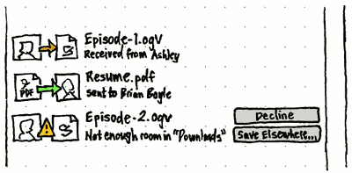

3.9.3. The device must provide accurate feedback about the failure reasons for a file transfer
The “File Transfers” window should show, for each transfer, text corresponding to its status, its success, or the reason it failed. For example:
- “{name} has not authorized you as a contact”
- “{name}’s device cannot receive files”
- “{name} declined the transfer”
- “You cancelled the transfer”
- “{name} cancelled the transfer”

3.9.4. The device must enable cancelling an in-progress file transfer
No work required.

3.10. Optional: Skype contact search and adding contacts
Skype contact search is already implemented. Collabora should ensure that it meets the following certification requirements.

Skype certification requirements
3.10.1 | The device must enable searching for contacts by Skype Name, e-mail, and full name.
3.10.2 | The device must enable viewing the person’s profile in search results … The information displayed is complete and correct.
3.10.3 | The device must enable the user to add a contact (send a new authorization request) from the search results.
3.10.4 | The device must enable declining, declining and blocking, and accepting authorization requests. A user who was declined and blocked should appear in the list of blocked users.
For more information and discussions see the bug report.
https://bugzilla.gnome.org/show_bug.cgi?id=606947

3.11. Optional: SMS
No work required. Empathy does not currently send SMS messages.

3.12. Optional: Video
These requirements are not optional, because Empathy already allows video calls.

3.12.1 The device must enable stopping and starting video during a Skype call
No work required. Empathy already allows turning the camera on and off during a call.

3.12.2. The device must enable the user to choose whether the call starts with or without sending video
No work required. This is already implemented as a checkbox for incoming calls.

3.12.3. The device must provide feedback to the user indicating whether video is being sent
No work required.

3.12.4. The user must be able to display the video of himself during a video call
No work required. Empathy already shows the video of yourself.

3.12.5. The device must disable video-related functionality if a camera is not connected
Whenever no working camera is available:
- The video camera widget should not be present next to contacts that can make video calls.
- The “Send Video” checkbox should not be present in the “New Call” dialog.
- The “Camera Off”/“Preview”/“Camera On” buttons should not be present in the call window.
- The “Video Input” panel should not be present in the sidebar of any call window.

3.13. Optional: Public conversations — hosting
No work required. Empathy does not currently host public conversations.

3.14. Optional: Public conversations — participating
No work required. Empathy does not currently allow joining a public conversation.

4. Quality and reliability requirements

4.1. General quality requirements

4.1.1. the product does not physically break when tested
Not applicable.

4.1.2. The solution must not contain relics
Purpose: The solution must not contain visible redundant items (ports, menus, keys). In order to avoid misleading the user, they should be hidden even if they are related to some secondary use cases.

4.1.3. The solution must be intuitive to use
Purpose: To verify that the solution is intuitive to use. During the interaction with the product, the need to consult user manuals and other external information should be minimized. The overall usability of your solution will be assessed in the light of the Skype user experience guidelines. Usability principles include providing appropriate and timely feedback, making the most common tasks most prominent, handling errors properly, and so on.

4.2. Embedded Skype device requirements
No work required. Steve Pearce says Empathy is not an “embedded Skype device” in this sense.

Possible further enhancements
This section covers various features and changes that could be applied to Empathy, to make it more attractive to Skype for certification, or to OEMs once the certification requirements are met.
Any “Plugged into Skype” requirements and Skype certification requirements cited in this section are included either because they need to be taken into account when changing an existing compliant feature, or because they need to be complied with when adding a new optional feature.

Showing “Offline with voicemail” status
For a Skype contact, call forwarding mode (“Offline with voicemail”) should be shown using a distinct icon.

Skype-specific sounds
When a Skype account connects and “Account connected” is checked in the Sounds settings, the sound played should be the branded Skype one.
When there is an incoming Skype call, the ringtone should be the branded Skype one.
When a message is sent or received in a Skype chat and “Message sent” or “Message received” is checked in the Sounds settings, the sound played should be the branded Skype one.

Country calling code help when dialling a number
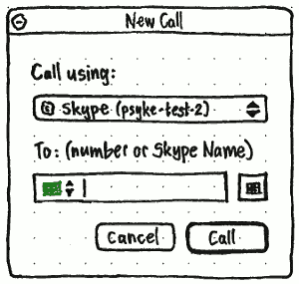
In the “New Call” dialog, the field for entering a number or Skype Name should begin with a flag icon and a pair of triangles, indicating that you can click the flag or triangles to open a radio menu.
Like any other radio menu, when it opens this menu should be positioned so that the current selection appears under the pointer. The menu should contain one item for every current ITU-T-recognized international dialling code. Each item should have a flag icon representing the country or region.
Selecting an item from the menu should:
- remove any international dialling code currently in the field
- remove any leading zero from the field
- insert the appropriate international dialling code, followed by a space if there isn’t one already.
For example, if the contents of the field is currently “+3890123456789” (Macedonia code 389, a spurious 0, then a number), and you choose “Malta”, the contents of the field should become “+356 123456789”.
Conversely, if you insert or edit an international dialling code in the field yourself, the flag icon (and the selection, if you subsequently open the menu) should update automatically to reflect the new value. For example, if the field contains “+1470123”, and you change it to “+1473123”, the US flag should change to a Grenada flag.

On-demand installation of Skype module
Even when the Skype module is not installed, Empathy should present “Skype” as a possible account type to add.
In this situation, when you choose “Skype”, the rest of the “Add account” pane should be taken up by the text “To set up a Skype account, you need to install extra software, including proprietary software from Skype.”, and an “Install Skype Software” button.
Choosing “Install Skype Software” button should replace that text and button with an “Installing Skype software…” progress bar and “Cancel” button. (The “Cancel” button should become insensitive when the installation is too far through to be cancellable.)
Once the installation is complete, the progress bar and “Cancel” button should, in turn, be replaced by the appropriate fields for setting up a Skype account.
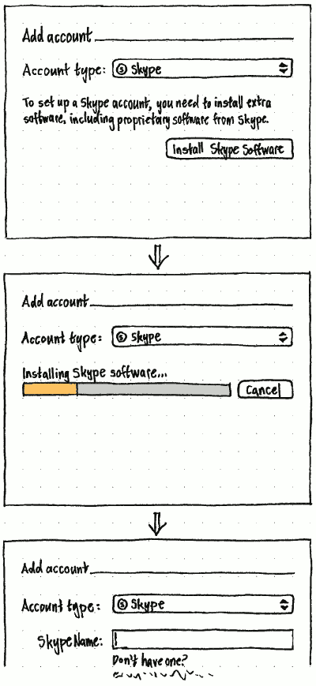

Voicemail
This section covers new functions for voicemail that an existing desktop Skype user would expect to find:
- setting up voicemail for a Skype account
- configuring when an incoming call should be sent to voicemail
- recording a voicemail greeting
- receiving voicemail from an incoming call
- playing back voicemail
- recording voicemail for an outgoing call.

Skype certification requirements
3.4.9 | The user should be able to leave a voicemail to another Skype user.

Voicemail settings
The “Preferences” window should have a new panel labelled “Voicemail”.
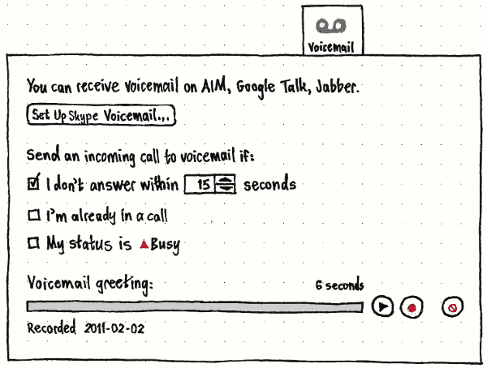
The panel’s intro sentence should either be “You have no accounts set up to receive voicemail.”, or be of the form “You can receive voicemail on {comma-separated list of protocols}.”, whichever is true.
If Skype integration is installed, and you have a Skype account set up, and your Skype account does not have voicemail set up, the intro sentence should be followed by a “Set Up Skype Voicemail…” button that opens a browser to the Web page for setting up voicemail. In all other cases, the button should not be present at all.
If you have no accounts set up that can receive voicemail, the rest of the controls in the pane should be present but insensitive.
On the trailing side of the “Voicemail greeting:” playback bar should be:
- a Play button for the current greeting, which becomes a Stop button during playback;
- a Record button for recording a new greeting, which becomes a Stop button during recording; and
- (a little further away) a Delete button, sensitive only if you have a custom greeting (or have started recording one), for deleting that greeting and reverting to the default one.
Before recording, a tone should play for one second. During recording, the playback bar should be indeterminate. During playback, the playback bar should fill. At all other times, the playback bar should be empty.
Above the playback bar, the caption at the trailing end should be the duration of the recording in progress, if it is, or otherwise the duration of the current message. Below the playback bar, the caption should be of the form “Recording” if you are currently recording, otherwise “Recorded {date}” if the current greeting is a custom one, or “Default” if it is the default one.

Sending an incoming call to voicemail manually
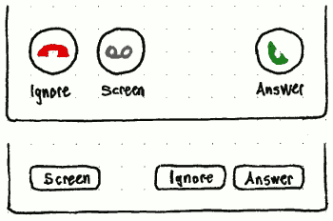
However an incoming call is presented, whenever it is being made through an account that has the ability to record voicemail, the prompt to answer the call should have an extra “Screen” button that dismisses the prompt, and silently plays the greeting and records a voicemail message. The presence of the “Screen” button should not alter the placement of the other buttons.

Being notified of voicemail
Whenever you have voicemail messages that you have not yet dealt with:
- The messages should appear as individual items in Ubuntu’s messaging menu, with correct timestamps, and the icons and names of the contacts who recorded them. Activating any of these menu items should open the Contacts window if it is not open already, switch to its voicemail view (described below) if it is not already, select that message in the list, and if the message is not completely visible, scroll the list just enough so that it is.
- At the bottom of Empathy’s Contacts window, there should be a placard with a messages icon and text of the form “2 new messages”.
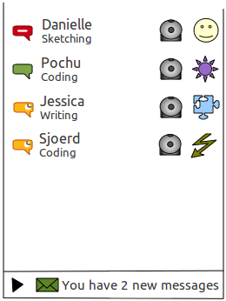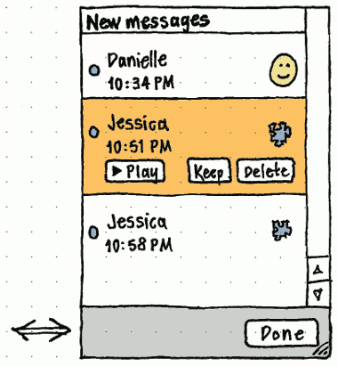

Playing back voicemail received
Clicking anywhere in that placard should flip the contents of the Contacts window into a “New messages” view (like the “Blocked users” view) that lists the messages in chronological order, with the contact’s name and profile icon for each message, and time the message was received (and the date, if it was before today). In the place of the “new messages” placard should be a placard containing a “Done” button for flipping back to the normal contacts view.
Whenever a message is selected, a “Play” button (with icon) on the leading side, and “Keep” and “Delete” buttons (without icons) on the trailing side, should be visible in the selected row. “Play” should toggle to “Stop” whenever that message is being played. Starting playback of one message should automatically stop playback of any other messages. The “Keep” and “Delete” buttons, in addition to their respective functions, should also stop playback and remove the message from view. A message should persist in the list, even between Empathy sessions, until you have chosen “Keep” or “Delete”.
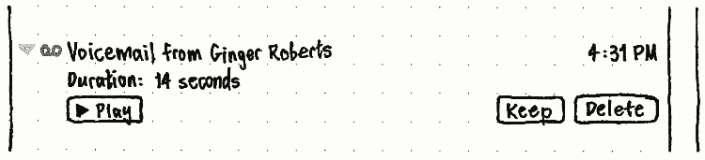
Add a playback bar here.
In the History window, the same “Play”/“Stop”, “Keep”, and “Delete” buttons should appear for an expanded voicemail message event — except that “Play” and “Delete” should be present only if the recording is still available, and “Keep” should be present only if you have not yet decided whether to keep or delete the message (i.e. it is still in the “New messages” list).

Leaving a voicemail message
Re-recording could be a separate feature.
Some protocols (but not Skype) allow video voicemail.
Whenever an outgoing call you are making is received by a voicemail service that allows re-recording of messages, the normal call window should contain a playback bar and other controls for replaying and re-recording your message, similar to those used for the greeting message in the voicemail settings.
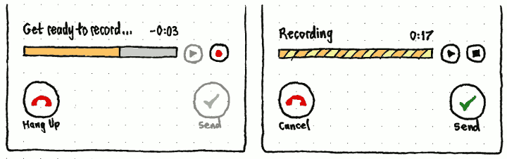
While the greeting message and prompt tone are being played, the playback bar label should be “Get ready to record…”, the caption should count down (in the form “−M:SS”) the time until recording will begin, the playback bar should show the proportion of greeting message + tone that has played so far, and the Play and Send buttons should be insensitive (because there is not yet any message to play or send). If you press Record, the remainder of the greeting message should be skipped, with only the tone being played before recording begins. Alternatively, if you let the greeting message play to completion, the Record button should visibly press itself and recording should begin automatically.
While recording, the playback bar label should be “Recording”, the caption should count up (in the form “M:SS”) the duration of the recording so far, the playback bar itself should be indeterminate, and the Record button should temporarily be a Stop button. Pressing any of the other three buttons should also stop the recording, as well as performing their respective functions.
While you have recorded a message but it is not currently playing, the playback bar label should be “Message ready to send”, the caption should be the duration of the recording, and the playback bar should be empty.
While you are playing back your message, the playback bar label should be “Playing”, the caption should count up how far through the message you are, the playback bar itself should fill to show how much of the message has played, and the Play button should temporarily be a Stop button. Pressing any of the other three buttons should also stop the recording, as well as performing their respective functions.
From the moment you first start recording a message for a call, the call’s “Hang Up” button should be relabelled “Cancel”.
For more information and discussions see the bug report (mostly technical discussions around implementation):
https://bugs.freedesktop.org/show_bug.cgi?id=24901

SMS

Skype certification requirements
2.1.3 | …If the device supports sending SMS then the user manual must describe how to confirm a mobile number.
3.11.1 | The device must enable the user to send an SMS to a Skype contact with a mobile number.
3.11.2 | The device must enable the user to send an SMS to a phone number whether or not it’s stored in the contact list.
3.11.3 | The device must inform the user about the status of sending the SMS.
Preliminary sketches:
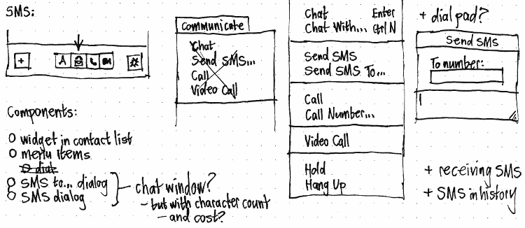
+ status/progress of sending
Preliminary notes:
If someone goes offline while you’re chatting to them, should you be able to finish the thought as an SMS?

Refined search and adding of contacts

Skype certification requirements
3.10.1 | The device must enable searching for contacts by Skype Name, e-mail, and full name.
3.10.2 | The device must enable viewing the person’s profile in search results … The information displayed is complete and correct.
3.10.3 | The device must enable the user to add a contact (send a new authorization request) from the search results.
3.10.4 | The device must enable declining, declining and blocking, and accepting authorization requests. A user who was declined and blocked should appear in the list of blocked users.

Adding a contact
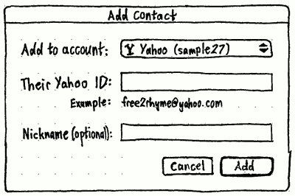
When the protocol or server for the selected account does not offer contact search, the rest of the “Add Contact” dialog should follow the standard two-column layout: right-aligned labels on the left, left-aligned controls on the right. But when the protocol and server do offer contact search (as Skype does), the only other elements following the two-column layout should be a pair of “Find contact by:” radio buttons, “{ID label}” and “Search”. (For Skype, “{ID label}” should be “Skype Name”, not “Skype name”.) The remaining elements should follow a vertical layout.
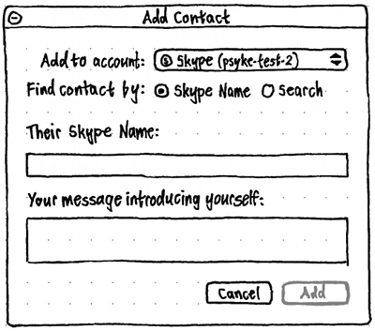
Whether “{ID label}” or “Search” is the default should be protocol-dependent: for Skype the default should be “Search”, while (for example) for Jabber probably it should be “Jabber ID”.
Whenever “{ID label}” is selected, the next field should be “Their {ID label}:”. If the protocol allows introductory messages, this should be followed by a multi-line “Your message introducing yourself:” field, with the default value “Please let me see when you are online. Thanks!”. The “Add” button should be insensitive whenever the “Their {ID label}:” field is empty.
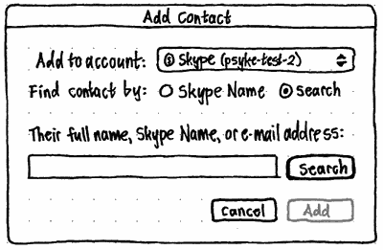
Whenever “Search” is selected, the next field should instead be a search field, with a protocol-specific label describing what you can search for. For Skype, it should be “Their full name, Skype Name, or e-mail address:”. The “Search” button should be the default button, but should be insensitive whenever the field is empty. At this stage, the “Add” button should always be insensitive.
Switching from “{ID label}” to “Search”, or vice versa, should resize the window vertically (but not horizontally) so that it just fits its new contents. It should also retain the text in whichever text field comes next, in case (for example) you started entering a full name in the “Their Skype Name:” field before realizing that you needed to search for it instead.
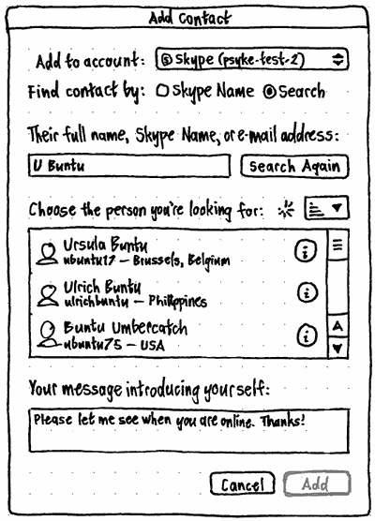
When you choose “Search” for the first time, the window should expand vertically to display controls for choosing a contact (even when results aren’t available yet) and for introducing yourself. The “Search” button should become “Search Again”, and should no longer be the default button.
The menubutton next to the “Choose the person you’re looking for” label should be sensitive only when there is more than one search result. It should have items for sorting the results, with the default being “Sort by Suggestion” (the default sort order returned by the Skype Directory).
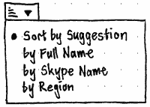
Whenever the directory is being searched, a spinner should appear, immediately to the leading side of the sorting menubutton, until the search results are complete.
If there is an error that prevents any search results arriving, an error message should appear the results field should appear centered horizontally and vertically inside the search results field:
There was a problem searching the Skype Directory.
Check your Internet connection, and try again later.
When there are results, the “i” button at the trailing end of each result should open the profile window for showing all public information about that Skype account.
Again, the “Your message introducing yourself:” field should be present only if the protocol allows it. The “Add” button should be the default button, but sensitive only when a result is selected. Activating “Add” should display a spinner in the bottom leading corner of the window, send an authorization request to the selected user, and then close the window.
In the Contact List, a Skype account to whom you have sent an authorization request which has not yet received a response should appear with a grey question mark icon, and the status text “Awaiting authorization”.
When a contact accepts your authorization request, a non-interactive notification bubble should appear, using the contact’s avatar icon, their full name as primary text, and “accepted your request to become a contact.” as secondary text. A translator note should explain how those primary and secondary text strings work together as a sentence.

Showing full profile information
When displaying a Skype contact, the standard contact Information window should have an extra section at the bottom, “Personal Info”, like the existing “Contact Details” section.
The “Personal Info” section should have rows for whichever other fields the contact has supplied in their profile. The “Web site” field, if present, should be a clickable link.

Incoming authorization requests
An incoming authorization request should be shown as an ordinary alert box that has no parent window and is never focused by default (since it did not open as a result of your action).
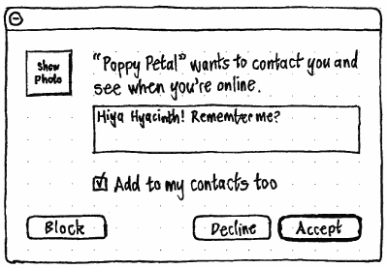
To guard against offensive profile pictures, instead of the standard icon for an alert, there should be a square button the same size as the icon would be, with the text “Show Photo” centered horizontally and vertically inside it. Clicking the button should turn the button into the profile picture of the person. Clicking the picture should turn it back into a “Show Photo” button.
To guard against scams, the name of the requesting account should be enclosed in quotes (“”), and if it is longer than 32 characters it should be ellipsized.
The message field should contain a scrollbar only if the text cannot display completely in the box.

Built-in account creation

Skype certification requirements
3.2.1 | The solution must inform the user if the account name is invalid.
3.2.2 | The solution must check the availability of the Skype Name.
3.2.3 | The solution must inform the user if the password is invalid.
3.2.4 | Password must be repeated by the user.
3.2.5 | The device must inform the user if the password and confirmation do not match.
3.2.6 | The device must enable cancelling out of creating a new account.
3.2.7 | The user must provide an e-mail address and an option is provided to receive news and information from Skype.
3.2.8 | The Skype End User License Agreement must be accepted.
Preliminary sketches:
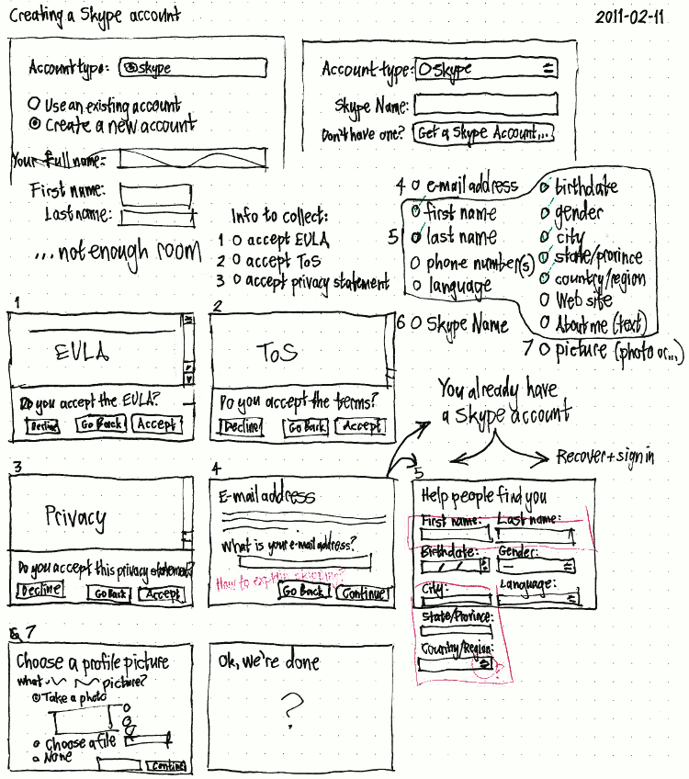
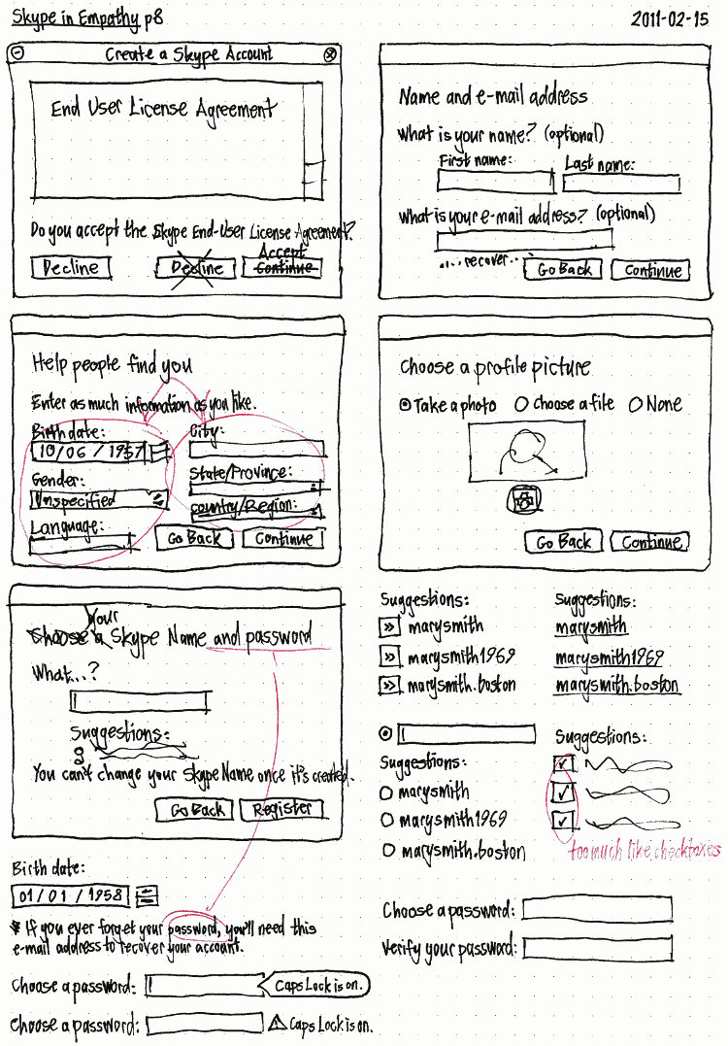
Preliminary notes:
The “No emergency calls” text should use Skype’s standard icon for this purpose.
In the EULA, terms of service, and privacy statement steps, to avoid misdirection from “Join Skype” etc navigation links, the assistant should apply to all three pages an extra style sheet that hides the Skype.com header and footer (#awesomeHeader, header, #awesomeFooter, footer {display: none}).
If the full name in your Ubuntu user account contains at least one space, The “First name” field should be pre-filled with the text before the last space, and the “Last name” field with the text before the first space.
The “Choose a Skype Name:” field should accept only those characters allowed in a Skype Name; any other character entered in any way (e.g. by typing or pasting) should be converted to a hyphen “-” immediately as it is typed.
Include the option to use the existing account picture.
Include a “Remember password” checkbox in the setup.

Built-in password changing

Skype certification requirements
3.3.1 | The device must verify the old password before allowing the password to be changed.
3.3.2 | The password must not be changed if invalid data is entered.
3.3.3 | The device must enable cancelling out of changing the password.
Preliminary sketches:
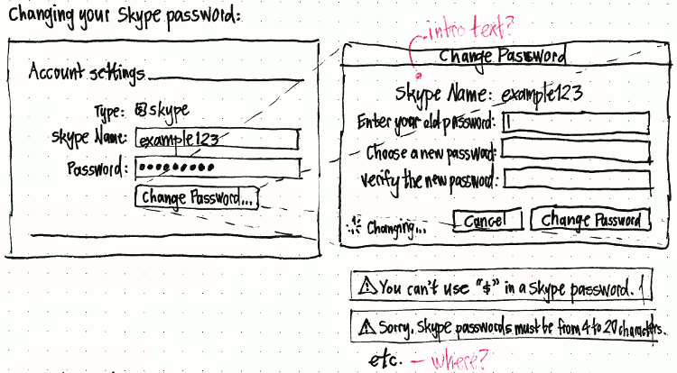
Preliminary notes:
The “Choose a new password:” field should play the alert sound on disallowed characters. The “Verify the new password:” field should accept disallowed characters, to check that you aren’t trying to use them.

Call holding/switching

Skype certification requirements
3.4.3 | The user should be able to put a call on hold or mute the microphone.
3.4.4 | The device must be able to handle an interrupting call.
Preliminary sketches:
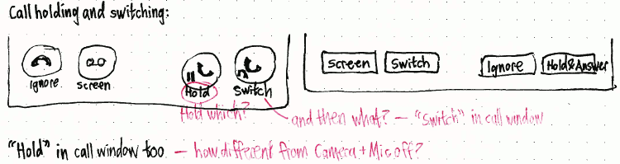

More obvious audio/video calls
Options I considered:
- Small audio and video emblems in each Contact List row, with the selected row expanding to show larger buttons. Pro: Compact and direct. Con: Emblem ↔ button transition is awkward, and individual buttons are confusing for group calls.
- A toolbar at the bottom of the window. Pro: Makes Empathy’s feature set more obvious to new users. Con: Indirect (two clicks in separate places to start a call), and eats vertical space.
- Large but light emblems in each Contact List row, that become heavy buttons on mouseover (like Skype). Pro: Highly direct. Con: Eats a lot of horizontal space, is distracting when scrubbing the list, confusing for group calls, and won’t scale to SMS or voicemail.
Least bad seems to be option #2.
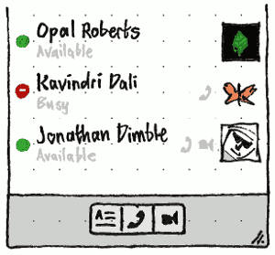
The bottom of the Contact List should have a toolbar with a button for each kind of communication that Empathy allows: Text Chat, SMS (once implemented), Audio Call, and Video Call. As with the shortcut menu items for contacts, the toolbar buttons should be sensitive whenever the selected contact (or contacts) allows that method of communication.
The existing camera button next to a contact should be replaced by small, grey, unclickable emblems showing whether the contact can accept audio calls, video calls, or both.

Group calls (conference calls)

Setting up a group call
As well as adding people to an existing call, it should be possible to start a group call from scratch.
Implementing this function, in a way that will be obvious, requires first implementing the more obvious audio/video calls.
SkypeKit currently does not allow video conference calls, and Empathy does not allow any conference calls with any other protocol. at all. hould we make the various Video Call functions insensitive if you haven’t paid for Skype Premium? Or should we leave them enabled because the last two remaining participants will go to video automatically when the others leave?

From the “New Call” dialog
The “New Call” dialog should have “–” and “+” buttons next to each participant, for removing and adding participants.
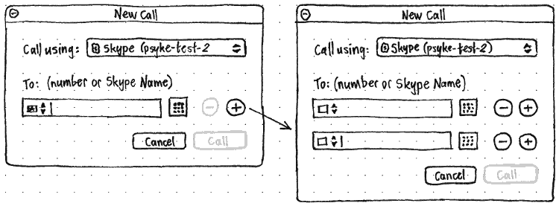
When there is only one row, its “–” button should be sensitive only if the field is non-empty, in which case it should clear the field. When there is more than one row, a row’s “–“ button should delete that row, with those below sliding up to fill the space. A row’s “+” button should add a new row immediately below that one (with those below it sliding down to make room), and focus its field.

By direct multiple selection
In the Contact List, it should be possible to select multiple contacts in the same way as for other lists that allow multiple selection: by Ctrl+clicking, Shift+clicking, Shift + arrow keys, and Ctrl + arrow keys and Space.
When multiple contacts are selected:
- the Text Chat command should be insensitive (unless group chats have been implemented)
- the Audio Call command should be insensitive if none of the selected contacts have a microphone
- the Video Call command should be insensitive if none of the selected contacts have a camera.

By adding participants to an existing call

Joining a group call, knowing who’s on it
When you receive a prompt to answer a call, if it is a group call, then instead of “from {Caller’s Name}” it should say “from {Caller’s Name} with {Comma-Separated Names of Other Current Participants}”.
Is this possible?

Seeing people on a group call
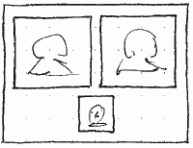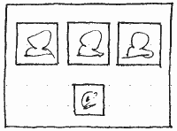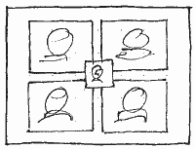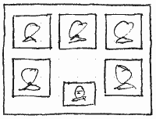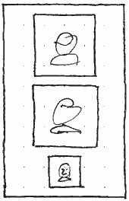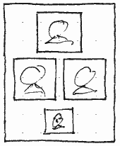
Whenever more than one other person is on a call, whether it is audio or video, each person’s video — or avatar, if available, with name centered underneath — should be shown in a video-aspect block inside the window. The blocks should be laid out in whatever grid or near-grid arrangement allows the largest blocks at the current window size, while being horizontally symmetrical and leaving as much padding between blocks as there is around the outside of the window. If this leaves any spare space, blocks that would overlap your own video block should move as far out of the way as possible. Whenever the window is resized, someone joins or leaves the call, or you show, hide, or move your own video block, each participant should slide smoothly to their new position, with the least rewrapping possible.

Telling who is talking on a group call
In any group call, whether audio or video, a person’s frame should (as in Skype) glow in proportion to the volume of sound being transmitted by that person.

Adding someone to a group call
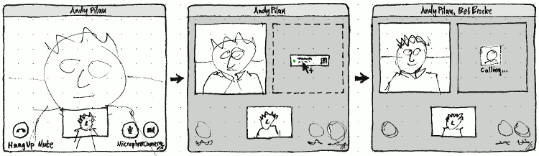
If you drag a contact near the center of someone’s video or avatar in a call window, it should (not as part of this feature) send the contact details to that person as a file. If you drag the contact anywhere else in the call window, and it is not possible for more participants to join the call, the cursor should turn into the can’t-drag-here pointer. But if it is possible for more participants could join the call, the current participants should resize and slide out of the way — temporarily, if you move elsewhere or cancel the drag — to make room for a dotted outline in the place nearest to the pointer where the new participant could go. If this will require the call to become audio-only, the video should temporarily be replaced by When you drop the contact, the dotted outline should be replaced by the normal placeholder for a person being called.
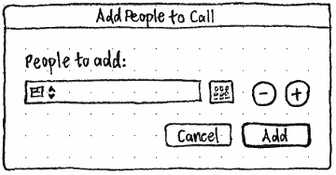
In a chat window’s first menu, there should also be an “Add People to Call…” item that opens an “Add People to Call” dialog the same as the “New Call” dialog, but (a) without the “Call using:” menu, (b) the label “People to add:” instead of “To:”, and (c) an “Add” button instead of a “Call” button.
What if someone doesn’t answer? Should they stay there so you can try again? If so, what happens if you then reach the maximum?

Cancelling adding someone to a group call
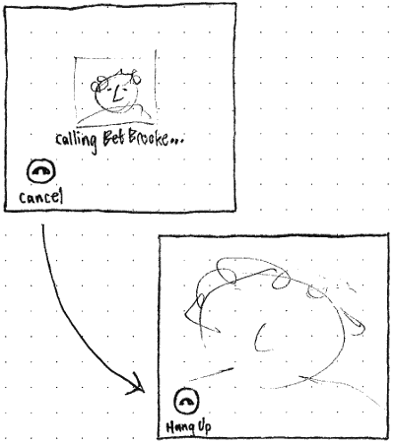
The frame for a person who is being called should have a “Cancel” button at its bottom left corner, like a smaller version of the main “Hang Up” button.

Seeing that someone else is adding someone to a group call
Is this possible in any protocol?
If someone else is trying to add someone to a call you are on, they should show up as the same kind of frame for someone you added yourself, but without the “Cancel” button.

Removing someone from a group call
Is this possible in any protocol?
If it is possible to remove someone from a group call, they should have an individual “Hang Up” button, in the same place as the “Cancel” button was while waiting for them to answer.

Showing that a chat message was edited

Editing your own chat messages

Public conversations — participating

Public conversations — hosting

Avoiding frustration from muted sound
When sound is muted, Ubuntu’s sound menu goes red when a program tries to play sound. However, someone may not see this, or they may have turned off the sound menu to save space, and it does not apply to microphone volume anyway. Being unaware of muted sound is especially frustrating when trying to make VoIP calls. Empathy could work around this by showing extra hints when speaker or microphone volume is muted.

Understanding that Skype disallows video on a free group call
This is not relevant as long as SkypeKit doesn’t allow video conferences at all.
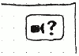
When no-one on a group call has Skype Premium, their frames should show their avatars, as it would if this was an audio call.
In addition, in the top right corner of the window should be a button with a symbolic camera icon and a question mark, and the accessible label and tooltip “Why is there no video?”. Activating the button should open a browser to Skype’s page about group video calling.

